# Purpose

This document will provide an understanding of the formatting, and language to be used when creating Gough Group SOPs

SOPs should be prepared by individuals who have a level of Microsoft Word skill that enables to work on long documents. This includes, but is not limited to:

* Apply the specified styles
* Align text using ruler and tabs
* Restart and continued numbering
* Update table of contents
* Insert and manage images: position, text wrapping, aligning, grouping
* Manage and adjust tables: border, row size, break rows across pages
* Fields: Updating, inserting (specifically cross references), showing filed shading
* Page orientation
* Headers and footers: Linking/unlinking to previous
* Using templates

# Use of icons

|  |  |  |  |  |  |
| --- | --- | --- | --- | --- | --- |
|  | **Business rule** |  | **Key point / Tips** |  | **Information** |

**What is covered in this guide**

1. Terminology 2

2. Consistent formatting 3

3. Correct grammar and punctuation 3

4. Writing style 4

5. Other hints and tips 4

6. Process for copying existing SOP into new template 5

7. Linking template 6

8. Turn on field shading 7

9. Working with images 8

10. Adding quick parts 10

11. Cross referencing 11

12. Changing table of contents 12

13. Change task heading to sentence case 13

## Terminology

|  |  |
| --- | --- |
| **Select** | Use the word select, this gives the SOP longevity as more touch screen devices are bought online. |
| **Choose** | Use the word choose when selecting an item from a drop-down menu |
| **Navigate and open** | To open a new NAXT menu path use the words navigate and open |
| **Filter to find** | Use the words filter to find when describing searching |
| **Will display** | Used to describe opening windows |

## Consistent formatting

|  |  |
| --- | --- |
| **Feature** | **Guideline** |
| **Styles** | Use inbuilt document styles to apply the correct fonts and spacing. |
| **Numbered lists** | Use the numbered list styles to summarise steps. These styles will apply numbers to the step, then letters for sub-steps.  Use style **‘List continue**’ for any thing that appears after a numbered or alphanumeric step that is not a new step. |
| **Pagination** | Each task should start on a new page. |
| **Screen captures** | Screen captures to be included where appropriate |
| **Annotations** | Use MS Word to edit and highlight key points on images (numbering and red boxes & arrows). This will enable ease of editing later. |
| **Bold** | Use **bold** formatting to highlight names of reference e.g. SOPs and tasks |
| **Italics** | Limit *italics* formatting to make comparisons, e.g. Select *open* instead of *closed*. |
| **Capitalisation** | When referring to anything on the screen, use the exact wording and capitalisation, as it is displayed on the screen and format using bold.  All task headings should use **sentence** case. |

## Correct grammar and punctuation

|  |  |
| --- | --- |
| **Feature** | **Guideline** |
| **Job titles** | Define job titles or unusual terms the first time they appear, followed by the abbreviation in brackets. |
| **Numbers** | Write the numbers 1 through 9 in words within the text. Write the numbers 10 and greater in the numerical form. |
| **List punctuation** | Do not use full stops at the end of each bullet  If the text that follows the bullet point is not a proper sentence, it doesn’t need to begin with a capital letter, nor end with a period. |

## Writing style

|  |  |
| --- | --- |
| **Feature** | **Guideline** |
| **Steps** | Write the steps as an order, assume that the reader is going to follow them step by step.  If there is more than one on-screen action required, these can be grouped into one step.  Use > to show a series of commands, for example:  **Open Accounts receivable > Common > Customers > All customers** |
| **Supporting information** | If supporting information needs to be shared, include it directly under the step it relates to.  Use one of the following options/icons business rule, information, or key point. |
| **Plain English** | Keep the sentences short, sharp and simple.  Write actively, e.g.,  Avoid using ‘you’. |

## Other hints and tips

|  |
| --- |
| Most common styles used when copying/writing a SOP   * Body text * Task * List number * List number 2 * List bullet * List contine * Table text |
| **F4** on your keyboard will repeat the last action |

## Process for copying existing SOP into new template

|  |
| --- |
| 1. Open the current SOP. |
| 1. Then create a new word document from the **SOP_Template.docx** |
| 1. Copy the introduction, terminology and if present pre-requisites from the old, into the new template. |
| 1. Copy the steps and paste under icons in the new templates |
| 1. Copy step headings from the table to sit above the steps they relate to, apply Task style, |
| 1. Review each headings to check that change acronyms back to upper case e.g. cat = CAT |
| 1. Select all task headings and change the case to sentence case. |
| 1. Delete all old heading rows, (use **F4**) |
| 1. Merge cells so you only have one column (use **F4**) |
| 1. Remove right and left table cell boarders |
| 1. Clear all font formatting from cell contents |
| 1. Set all font to List number (use styles) |
| 1. Start reorganisation of the SOP content.   The primary purpose of the SOP is for the reader to complete the task. Steps should be written assuming that the reader follows them sequentially. Make sure there is no repetition. |
| 1. There should be one action or screen being filled in per line |

## Linking template

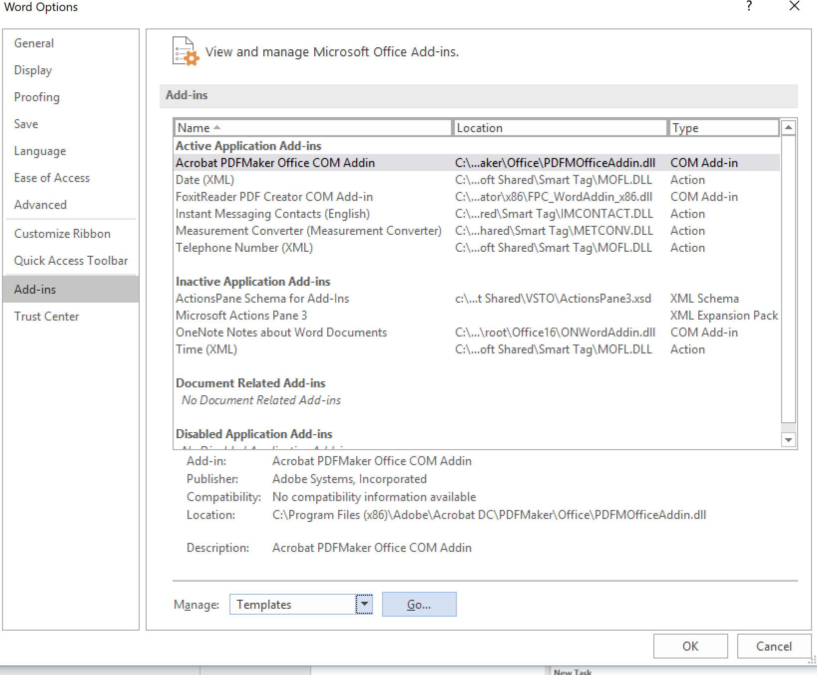

|  |
| --- |
| 1. Link the template select:    1. **File**    2. **Options**    3. **Add ins**    4. **Manage > Templates**    5. **Go** |
| 1. Find template file and attach |

## Turn on field shading

|  |
| --- |
| 1. Turn on field shading select the following options.    1. **File**    2. **Options**    3. **Advanced**    4. **Field shading always**    5. **ok** |
| Turning on field shading will quickly highlight to the reader/reviewer if the field has been linked. |

## Working with images

|  |
| --- |
| 1. All objects (images, numbered circles, shapes, lines) must be on the same layer to group them together as one image, |
| You might need to send the picture to the back if you have already added steps, boxes and lines. |
| 1. To group objects together from the home tab on the ribbon select    1. **Select > Select objects** |
| 1. Right click to group the objects in a single image. |
| 1. To use curvy red lines on images from the insert tab on the ribbon select **Shapes,** select **connector elbow arrow** |
| 1. When it appears on your image right click on the images and select **Connector types > curved connector** |
| 1. To insert red boxes onto images from the insert tab on the ribbon select **Shapes,** select the rectangle option. |

## Adding quick parts

|  |
| --- |
| The SOP template has been set up and includes quick parts, if the quick parts are not available to you, link your template see Section 7 Linking template |
| 1. The icons, steps and new tasks can be added via the quick parts menu item   Quick parts are found via the insert tab on the ribbon |

## Cross referencing

|  |
| --- |
| 1. Select **Insert > Cross reference** |
| 1. Select insert reference to    1. Paragraph number inserts the step or task number    2. Paragraph text inserts the task heading. |

## Changing table of contents

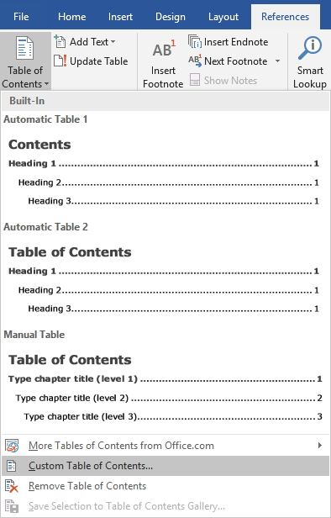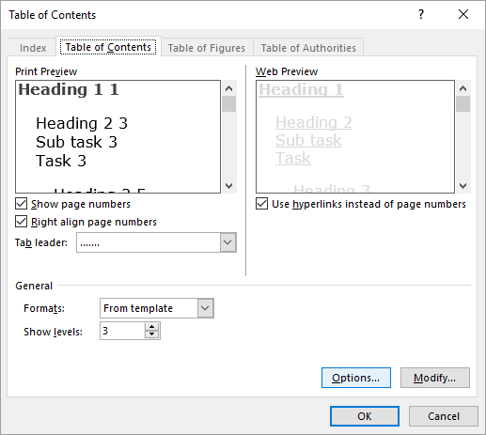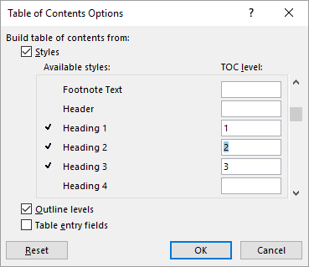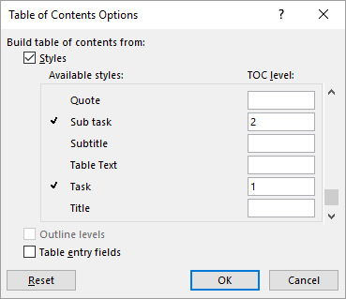

|  |
| --- |
| If sub tasks have been added to the SOP, create a new table of content to replace the existing |
| 1. Add a custom table of contents    1. Open references tab    2. Select custom table of contents    3. Select Options    4. Remove level numbering next to heading options    5. Add numbered heading to the task(1) and sub task (2)    6. Select **Ok** |

## Change task heading to sentence case

|  |
| --- |
| 1. Select all task headings right click on style, select **Select all** |
| 1. Change the case to sentence case |